**Question: 1**

| **Q** | **MC($)** | **TVC($)** | **TFC($)** |
| --- | --- | --- | --- |
| **0** | **--** | **0** | **100** |
| **1** | **182** | **182** | **100** |
| **2** | **158** | **340** | **100** |
| **3** | **152** | **492** | **100** |
| **4** | **164** | **656** | **100** |
| **5** | **194** | **850** | **100** |
| **6** | **242** | **1092** | **100** |
| **7** | **308** | **1400** | **100** |
| **8** | **392** | **1792** | **100** |

**Over what range of quantities does this firm experience increasing marginal product?**

1. **up to the 3rd unit of output**
2. Between 4th and 5th units of output
3. Between 6th and 8th units of output
4. Over none of the outputs

**Answer: A**

**A firm experiences increasing marginal product when its marginal costs are decreasing. after the third unit is produced marginal costs begin to increase, and marginal costs are increasing for 4 units and beyond.**

**Question 2: Please fill up this box for a firm’s daily production plan**:

| **L** | **Q** | **MP** | **TC** | **MC** | **TFC** | **AFC** | **TVC** | **AVC** |
| --- | --- | --- | --- | --- | --- | --- | --- | --- |
| 1 | 23 | 23 | 670 |  | 70 | 3.0 | 600 | 26 |
| 2 | 55 | 32 | 1270 | 18.75 | 70 | 1.27 | 1200 | 21.81 |
| 3 | 94 | 39 | 1870 | 15.38 | 70 |  | 1800 | 19.14 |
| 4 | 120 | 26 | 2470 | 23.07 | 70 |  | 2400 | 20 |
| 5 | 142 | 22 | 3070 | 27 | 70 |  | 3000 | 21 |
| 6 | 149 | 7 | 3670 |  | 70 |  | 3600 | 24 |

Solution:

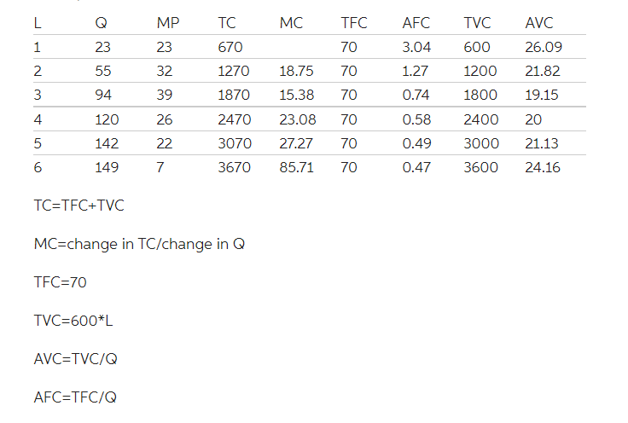

**Question 3: Calculate the average product and marginal product for the information provided in the table:**

| **Input of the variable factor Total Product (labor)** | **Total Product** | **Average Product** | **Marginal Product** |
| --- | --- | --- | --- |
| 0 | 0 |  |  |
| 1 | 21 | 21 | 21 |
| 2 | 58 | 29 | 37 |
| 3 | 68 | 22. | 10 |

**Solution:**

| **Input of the variable factor Total Product (labor)** | **Total Product** | **Average Product** | **Marginal Product** |
| --- | --- | --- | --- |
| 0 | 0 |  |  |
| 1 | 21 | 21 | 21 |
| 2 | 58 | 29 | 37 |
| 3 | 68 | 22.67 | 10 |

**Question 4**:

Fill in the table below:

| **Quantity of Cars** | **TC** | **VC** | **MC** | **AVC** | **ATC** | **AFC** |
| --- | --- | --- | --- | --- | --- | --- |
| 0 | 500,000 |  |  |  |  |  |
| 1 | 540,000 | 40,000 | 40000 | 40,000 | 540000 | 500,000 |
| 2 | 560,000 | 60,000 | 20000 | 30000 | 280000 | 250,000 |
| 3 | 570,000 | 70,000 | 10000 |  |  |  |
| 4 | 590,000 | 90,000 | 20000 |  |  |  |
| 5 | 620,000 | 120,000 | 30000 |  |  |  |
| 6 | 660,000 | 160,000 | 40000 |  |  |  |
| 7 | 720,000 | 220,000 |  |  |  |  |
| 8 | 800,000 | 300,000 |  |  |  |  |
| 9 | 920,000 | 420,000 |  |  |  |  |
| 10 | 1,100,000 | 600,000 |  |  |  |  |